Table of Contents

Notes/QA 1

Hypervisor 12

IGW 12

IP Address 12

Subnet Calculation 13

Page 1 14

Page 2 15

VPC 16

Steps to create a VPC 16

EC2 Instance 17

Deleting an VPC in AWS 17

NAT 17

Load Balancer for subnets 18

NLB 19

Security Group 19

EBS 20

# Notes/QA

* If your EC2 instance/server you created in different availability zones with different VPCs to connect the only way to use is "AWS Transit Gateway". Refer the image - <https://aws.amazon.com/blogs/architecture/creating-a-multi-region-application-with-aws-services-part-1-compute-and-security/>
* Routing table are nothing but kind of sign boards who routes the request into local or public
* We should not be using NLB for web browser (if your app is front end). Because NLB does not support host-based or path-based routing, SSL termination, and HTTP header manipulation. It simply passes the request to specified IP address/rule in the NLB configuration. Mostly recommended for backend applications.
* Infrastructure Security (Security groups in VPC / DNS Firewall/ Firewall Policy) is different from Application Security ( AWS WAF, Route53 , AWS Shield, Amazon Inspector finding issues with AMI )
* We can create an IAM policy using => [Policy_Generator_AWS](https://awspolicygen.s3.amazonaws.com/policygen.html)
* When you create an NLB for multiple AZ’s if your traffic performance or availability is not as expected please enable Cross zone availability feature ON (Load Balancer => Select your NLB => Attributes). This feature is costed
* We mostly use ALB as this overcome all the missed features from NLB(above). ALB can be used for front end , backend, etc., ALB has an option to redirect all HTTP request to HTTPS request through adding listeners
* We generally perform three types of deployment
  + Rolling Update/ In place Upgrade => Upgrading existing servers directly => Not recommended for PROD
  + BLUE-GREEN Deployments => For ex: change the Rules for ALB forward all traffic (100% weighted) from shows-v1 to shows-v2 Target Groups
  + Canary Deployments => Canary means It’s a small bird, where the human takes this bird inside a coal mine to find a poisonous if it’s there then bird die (so that human can pay attention and not to move forward or find alternative path)
    - For ex in AWS (Edit the rules for ALB): When new version is added shows-v1 to shows-v2 **We do not move all traffic** to new version & we move in weightage (70% load in shows-v1 & 30% load in shows-v2) and we monitor for one or two days then gradually we move 100% to new version

|  |  |
| --- | --- |
| **Question** | **Answer** |
| If you want EC2 VMs/Servers Public IP address to keep always static then create a new “Elastic IP address” and provide when you create a EC2 instance. Or else when you stop/Terminate/start your public IP address and domain name keep changing every time.   **IMPORTANT: Interview Qn:** Will the Public IP address changes when you reboot your EC2 instance? | No |
| Can we connect IGW directly? | No, because IGW does not have IP Address. |
| In Security Group how do we make sure the request information is validated not only the IP address? | Answer is We configure required IP address in Security Group AWS section, Also the integrate with third party Security group which does the IDS & IPS. Check in detailed in Security Group section here. |
| Can multiple VPC uses same IP Address? | Yes, until if the VPC does not connected using VPC peering in AWS |
| In Interview, they might ask how many gateways can be created in VPC? | Immediately don’t answer is 1, ask them whether it is VPW, IGW, NGW. |
| Can we have multiple IGW for a one VPC? | No |
| Can we move the Subnets (Range of IP address which is used to configure your server) from VPC to another VPC? | No |
| Is there a possibility to change the public IP Address of a Subnet or VPC? | No because by default it’s been assigned by AWS |
| Derive & tell the IP address range start & end for 10.0.0.0/9 ? | **Answer: 10.0.0.0 to 255.128.0.0**  Refer the subnet calculation section in the word document must |
| What is the purpose of “Edge associations” & “Routes” menu inside the VPC Routing tables | “Routes” => used to specify the IGW, VPC endpoints, Peering, TGW, etc.,  “Edge Associations” => Mainly used for Amazon Cloud front and AWS Global Accelerator where we can specify the traffic should route to our nearest edge location/on-premise centre so that it improves the performance and low latency. It serves better for customers with faster response |
| Can we add same route in “routes” menu and “Edge Association” menu in the RT tables for ex: IGW | Nope we cannot because then route table for the subnet gets confused which route it should prefer to use. |
| When you create a VPC or after you created the VPC by default AWS creates what? | Route tables, DHCP Options Set, Security Group, Network ACL |
| Do we have any limitations/restrictions for AWS services by region/availability zones (AZ)? | Yes, it might be for several reasons and there are many. For ex: AWS AppStream 2.0 is not allowed in China (Beijing) region. |
| List of Major AWS Services which can be used with or without VPC |  |
| Can we create /use a same subnet IP Address in another AZs under the same instance of VPC? | No, it throws an error from AWS console |
| Does AWS have a password enable functionality for EC2 instead of key-pair? | Partially yes, but by default EC2 instances are accessed by key pair by AWS during the EC2 instance creation which is recommended approach for security reasons. Still, you can achieve the password authentication with in the EC2 instance via sudo commands which is below:  • [Sudo su –]  • passwd “username” for ex: passwd “ec2-user”. • nano /etc/ssh/sshd_config • Locate the line for “Password Authentication no” and change to “Password Authentication yes”. • CTRL+X => then press Y and ENTER  • **Enter the following cmd:** Systemctl restart sshd |
| Do you enable the public Ip address when you create a EC2 instance? | No, by default we disable when we are creating this field for security purpose. We can enable this option only for learning purpose. |
| How do you export and import a key pair from one region to another region ? | Go to the region where you created the keypair and launch a EC2 machine and type “ec2-metadata” or “cat .ssh/authorized_keys” and find for word start with “ssh-rsa” copy whole (till the key name of the text) and paste in another region Key pair using Import key pair . |
| I want to access the private subnets from the internet? | As this a private subnet it can be achieved through NAT Gateway or creating a Load Balancer in one public subnet. (By default, Load balancer can access the private subnets) |
| How do you check whether the instances are able to reachable or connectable in AWS? | For VPC, in AWS we have “VPC Reachability Analyzer” (its paid for every analysed path) |
| Can we associate an elastic IP address for subnets which doesn’t have any instances | No, it is not possible to associate an Elastic IP address with a subnet directly, as Elastic IP addresses can only be associated with instances or network interfaces |
| Can we create an Elastic IP for private subnet in AWS | No, this is only for public subnet. For private subnets we use NAT gateway |
| Can we create an NAT gateway without an elastic IP address? | • No, Elastic IP is mandatory for NAT gateway which is used to send or receive the requests from internet.  • However, since the NAT gateway is in a private subnet and has no public IP address, traffic from the NAT gateway itself cannot reach the internet. It is designed to handle outbound traffic from private subnets and is not meant to receive inbound traffic |
| Can we create and associate the Elastic IP for instances and Gateways (forex: NAT)? | Yes, its allowed. we need to create an elastic IP and select “Instance” (EC2) for Gateways select “Interface” |
| How do you access private servers/subnets (app/web/DB EC2 servers) which are using NAT gateways from outside via public subnet? | It can only be done using **“Application Load Balancer (ALB) with the help of Target Groups”**  **Ex:->** |
| When you create an ALB do you keep in public or private subnets? | **It depends on: because ALB has two Internet-facing and Internal**  **Always for Public subnets (not for instances),** **why? See below error when you select private subnets you AWS throws a below error because the below one, we need to use Internal option in ALB which can be communicated between the private subnets (below image)** |
| What is the command to check how much of EBS volume used for an EC2 instance?  Or  How much of volumes your EC2 instance consumed? | Open the EC2 instance and type the following command **“df -h”** |
| How many VPC endpoints do we have and what are those? | There are two types:  Interface Endpoints: (used for all apart from Dynamo DB)  When you create Interface VPC endpoints remember it does not get added into Route table and it gets added into Network Interfaces for each Interface VPC endpoints (EC2=> Network Interfaces)  To identify Interface endpoints List: (VPC => endpoints => search Type=”Interface”)  • This type of VPC endpoint is used to connect to services powered by AWS PrivateLink.  • These endpoints are powered by Elastic Network Interfaces (ENIs) and allow you to connect to the service directly from your VPC without the need for a NAT instance or internet gateway  • They are used for accessing other AWS services, such as Kinesis, CloudWatch, and AWS Systems Manager, over a private connection.  • An interface endpoint provides a scalable and highly available path for traffic to and from the service. Interface endpoints can be created for services that do not support VPC endpoints or for services that support VPC endpoints but require additional features, such as custom DNS names or more granular security groups  Gateway Endpoints:  To identify Gateway endpoints List: (VPC => endpoints => search Type=”gateway”)  • When you create any Gateway VPC endpoints it gets added into the route table of your subnets  • This type of VPC endpoint is used to connect to services that support VPC endpoints through a gateway, such as Amazon S3 and DynamoDB. Gateway endpoints provide a scalable and highly available way to access these services from within your VPC without the need for an internet gateway or NAT instance. |
| Can we keep NAT & VPC endpoint both in Routing table for Private? | Yes, we can because **NAT used for internet access** purpose. But VPC endpoint is used to **connect the AWS services internally** (it does not have any relation with NAT and does not require any internet) |
| What you do if you lost the. PEM or .PPK file and how will you be able to login to server? why do I need to use? | System Manager (Under the Management & Governance Services option)  • Session Manager is a fully managed AWS service that provides secure and auditable instance management without the need for SSH or RDP access. It allows you to manage your instances remotely through a secure connection, giving you interactive shell access to your instances using the AWS Management Console, the AWS CLI, or the AWS SDKs  Key Benefits:  • Secure: The communication between the client and the instance is encrypted using SSL/TLS. It eliminates the need for inbound SSH or RDP ports, which can be a security concern  • Centralized control: You can control and audit user access to instances centrally and monitor all session activity through CloudTrail  • No additional software: You don't need to install or maintain any additional software on your instances  • Seamless integration: Session Manager integrates with other AWS services like AWS Identity and Access Management (IAM) and AWS Key Management Service (KMS) |
| I can use SSH commands to access my EC2 instances without session manager why do I need? | Yes, you can use SSH without Session Manager there are problems in security & centralized control.  • Improved security: With SSH, you need to open incoming traffic in your security group for SSH port 22, which can increase your attack surface. Session Manager uses an encrypted tunnel between the client and the instance, so you don't need to open any incoming traffic  • No need to manage SSH keys: With Session Manager, you don't need to manage SSH keys, which can be a security risk if not properly managed  • Centralized control and auditability: With Session Manager, you can centrally manage and audit user access to instances. You can control who has access to instances and what actions they can perform on the instances  • No need for a bastion host: With SSH, you typically need a bastion host to manage SSH connections to instances in a private subnet. With Session Manager, you don't need a bastion host since the connection is established through the Systems Manager service |
| Can we create a EBS volume for the EC2 instance in different AZ map to EC2? | Nope, we cannot create EBS volume and map to EC2 which are available in different AZ, Always EBS and EC2 must available in same AZ |
| Can we increase /decrease an EBS volume after its created? | Increase volume: Yes, it’s possible to increase EBS volume after its created.  Decreasing the volume is not straightforward actually the answer is NO. but we can achieve in alternative way that we can create a new volume and copy the old volume data to new volume (then detach from the instance) and attach the new volume to the instance. |
| Does the newly increased EBS volume size automatically assign to an existing partition drive? | Not automatically assigned to existing partition, not even the File system is extended to extend the partition we need to run few commands for ex: linux machine  Here after increased 3 to 5 GB xvdf (EBS volume) size is 5GB but the partition/file system size is not increased.    To achieve the file system size to be increased then refer below (growpart command)  (below image)    Now to extend a partition use (resize2fs for linux) for windows we can use the tool inside the OS. Recommendation is to take a backup of the volume before we proceed further.  Command: resize2fs /dev/xvdf1 |
| How do you connect AWS or any cloud to ON Premise or to any other cloud? | Using Site to Site VPN connections with the help of VPG/TGW  For ex: AWS to Azure Cloud connection  • First, we create CGW and add the public IP of your Azure VNG not the VM (Virtual Network Gateway)  • Secondly, add VPG/TGW then add that into all subnet route tables. If TGW then create a TGW attachment as well for subnets (AWS-10.11.0.0/16, 10.12.0.0/16) including the azure subnets (192.168.0.0/16)  • Finally, create a Site-to-Site VPN connection download the VPN configuration and extract Tunnel 1 & 2 information and add it to Azure VNG (VNG => Connections along with Local Tunnel creation where you can add the IP address of AWS tunnel and passwords)  Refer the example Tunnel Configuration file  Below diagram for VPG with VPN for reference but Optimistic solution to go with TGW |
| Do we need to do VPC peering if we use VPG or TGW? | • Not required of VPC peering when we use VPG but we need to create an VPG for each VPC in each region (which is pain)  • In advanced now, Not required for VPC peering but we can use only one Transit Gateway and Transit Gateway attachment for each VPC  Both VPG & TGW does internally achieve the VPC peering logic. |
| What is the other option instead of using VPN to connect AWS cloud to On premise?  (OR)  Is AWS VPN better for Performance to connect AWS cloud to on premise? | AWS DIRECT Connect is best option but it costly one.  When you connect AWS cloud to on premise or any other cloud the flow is over the Internet via VPN connection. If the internet bandwidth is not good then performance can impact so I would suggest to go with AWS DIRECT Connect |
| DNS firewall & Network Firewall | DNS firewall is used to block any request from specified domain names which in the Domain Lists and in the Rule Groups. We also have many 3rd party DNS firewall tools in the market like Quad9, Cisco Umberlla, etc.,  Section: VPC=> DNS Firewall  AWS Inbuilt Network Firewall mostly not used by many companies because it’s implemented few years so most of the companies has their own/third party firewalls like F5, etc., |
| What is the security flow when client initiate a request to System? | Client => Route 53 (Inbuilt DNS Resolver) => IGW (Which is mapped in Edge association) => DNS Firewall => Network Firewall => Security Group => Route Tables => EC2 Instance |
| What are the OSI model or seven 7 layers? | Application Layer (Layer 7) - User Interface (e.g.,Web Browser/backend code)  Presentation Layer (Layer 6) - Data Encryption/Decryption  Session Layer (Layer 5) - Login/Logout Sessions  Transport Layer (Layer 4) - Transmission Control Protocol (TCP)  Network Layer (Layer 3) - Internet Protocol (IP)  Data Link Layer (Layer 2) - Media Access Control (MAC) Addressing  Physical Layer (Layer 1) - Network Cabling or Wireless Signal  (Refer below image)  AWS services as reference for each layer below but many are there: |
| How do you fix/find the security vulnerability in EC2?  OR  What is Server Hardening ? | Amazon Inspector agent can be installed in the machine which finds and produce the report with all security vulnerability to fix in a batch. We can use Ansible for bulk update.  • First, we need to create an Amazon Inspector => Assessment Targets => Assessment Templates (Select the 4 rule packages below ) => Then the results can be viewed in Assessment runs section with detailed report  • Then to reduce the vulnerability shortest way is to use Ansible which focuses and deletes automatically.  Note: In the organization mostly, they use their own AMIs (which is after fixing the vulnerability on the EC2 machines not the public one) |
| How do you create an AMI image on a EC2 instance through automation ? | • Hashicorp Packer (For automation building images and deploying images not IaaC)  • AWS EBS-Life Cycle Manager (Which does both AMI including the volume, Snapshots of Volumes only not the entire machine) |
| What is the difference between TLS and HTTPS?  OR  What is the benefit in TLS | TLS (Transport Layer Security) and HTTPS (Hypertext Transfer Protocol Secure) are not the same, but they are related  HTTPS is a protocol for securely transmitting data over the internet. It uses the standard HTTP protocol but adds an additional layer of security by encrypting the data using SSL/TLS. HTTPS is used to protect sensitive information such as credit card details, passwords, and other personal information from being intercepted by unauthorized users.  TLS is a protocol that provides encryption and security for data transmission over a network. It is the successor to SSL (Secure Sockets Layer) and is used to provide security for various protocols, including HTTPS. TLS provides a secure communication channel between two endpoints (Source and Destination) by encrypting the data transmitted over the network. |
| Can NLB redirects the HTTP to HTTPS by default? | No |
| I have ALB and TG which are mapped 3 EC2 instances its working as expected, now I removed(Deregistered) 2 machines from TG but the still my traffic is going to those two machines why? | It’s because, When we remove (Deregister) any machines from TG by default (it will get deregistered 600 seconds later). If you want you can edit the default settings in (Attributes section) and reduce the seconds. |
| How do you block few IP address to access your application ?  Or block few countries not to access your websites | Amazon WAF => Create IP Set (for Ip address blocking) => Create Web ACL and map the created IP Set (through the rule type of “IPSet”) => Refer more on screenshot document  For country: Create Web ACL => Select the “Rule Builder” => Choose the country option and select the country and block |
| What is ACL | Access Control Lists |
| How do prevent DDoS attack (Distributed Denial of Service) or not to allow few countries or IP Address to access the URL | For DDoS attack => We use AWS Shield ( for a month $3000 fee) it’s a costlier one but it can prevent all fake traffic if someone/some company wants to make your service down (when they initiate fake traffic real traffic users wait time increase and they feel bad with satisfaction)  Block/Allow few countries => Create Web ACL (check above questions) |
| What are the different types of autoscaling in EC2? | Target Scaling (based on weightage of load) , Step Scaling(cpu utilization) , Simple Scaling  All these scaling when you create inside ASG you need to map/create an SNS topic and CloudWatch Alarm |
| Route 53 Routing types | Simple Routing: It’s a routing we can configure where the traffic/request to be forwarded (lb, IP address of ec2, etc.,)  Fail Over: When your region down (unhealthy) all the routes/traffic will be routed to healthy region automatically ( Strictly two regions , Primary [for ex: us-server] and secondary [for ex: ireland-server] we can’t configure more than two here)  Latency: It’s used to provide the better experience to user from the nearby region and services (Route 53 checks the location of request which is received and routes to the nearby location which has a lowest latency )  Weighted: Its similar to Load balancer including the proportion of a traffic.  Geo Location: Request/Traffic can be forwarded to specified region for ex: We can configure all the traffic should move to India server whoever hits from U.S  Multivalue answer: Where we specify the list of Machine IP address when we configure this in Route 53. When any request it reaches to Route53/DNS query returns the all the IP address so that user browser can choose which IP address and the send the request. (you can see this using “nslookup www.ragulawslearning.shop”  IP-based: Direct traffic based on the specific IP address of the client, rather than the location of the DNS resolver. For example, you might have a set of clients that have a specific IP address range, and you want to direct their traffic to a specific set of servers. Few examples below :  • Restrict access to the specific IP address,  • LB traffic across these data centres based on the geographic location of the client. You can use IP-based routing in Route 53 to achieve this. When a client sends a DNS query, Route 53 will look at the source IP address of the client and route the request to the data centre that is closest to the client |
| What are the disadvantages or it cannot be done using Route53 ? | Port based forwarding , SSL offloading, Targeting particular IP address (this one clarification or study required) |
| Can we create multiple routing in Route 53 for the same DNS (domain name) ? | Nope, it’s not possible because we specify the domain name when creating the record in Route 53 routing |
| What is global Accelerator ? | • Global Accelerator is to overcome the disadvantages of Route 53 features where we can forward a request/listen based on the ports to EC2 instance/ALB, NLB, Elastic IP address and also, we can specify weight of traffic which needs to go which region or zone EC2 instances ( for example I have servers in US , EU, CA and I can externally mention/configure with EC2 machine for each region and mention the traffic weight – US (50%) , EU (25%) ) like LB.  • IMPORTANT: We can specify multiple ports in Global Accelerator with the comma separation (ex: 80, 443) => PORT forwarding  • By Default, it forwards the traffic based on the Geo region we don’t need to create separate Geo-Location based routing in Route 53  • Main Advantage is WE DO GET TWO STATIC IP ADDRESS & ONE DNS NAME URL (similar to Load balancer URL) that never changes and it can be used or given to clients. It can be accessed anywhere from the world  • Once we created the Global Accelerator , we can map with Route53 Domain Name so that it makes more better  • Can add or remove endpoints in the AWS Regions, **Run blue/green deployment and do A/B texts without needing to update the IP addresses in your client applications**, firewalls and DNS records. |
| Which would you prefer Route53 or Global Accelerator ? | • If it’s one or two regions , I would suggest to use Global Accelerator.  • If the application is wider/bigger and expected to be available in multiple regions across the world then we go with Route53 (Latency Routing Option as latency will be reduced and serving customer can be better)  • Can add or remove endpoints in the AWS Regions, **Run blue/green deployment and do A/B texts without needing to update the IP addresses in your client applications**, firewalls and DNS records. |
| How do you decode the AWS error Message ( which is encrypted by default ) | Copy the Encrypted error message and open Terminal/CMD or AWS Cloud Shell and execute below command :  “aws sts decode-authorization-message --encoded-message {Encrypted_Error_Message}” |
| **“IAM Policy Evaluation Logic”** Diagram | In a IAM policy JSON if you have a 2 Actions for the resources (for ex: S3 ) , One is with “ALLOW” and other one “DENY”.  Always the AWS takes the higher priority for “DENY” and the user will not be able to access S3 here. |
| How can you restrict the policy which you created with in user/group level and hide that policy to the Other IAM users/groups ? | Create an IAM Policy using “Customer Inline” (By default the policy gets created as “Customer Managed” which is visible to other IAM users on the same account or organization ) |
| Do we require or add an access key, PWD during the IAM role creation? | No, when creating the IAM role but default AWS creates the new Access Key and password along with Token (The token is valid for 6 hours) |
| What is Permission Boundary in IAM ? | • **Permission Boundary** does override the policy which are created individually under the **Permission Policies** section for the user wise in IAM  • Permission Boundary can be automated from Lambda (for ex: when we create a new user as “TestUser” and create a policy as “AdministratorAccess” ) automatically lambda writes a new Permission boundary under the “Permission Boundary section” for the same user. |
| What is Identity Center vs General IAM users in IAM ? | • IAM General users, groups, roles are accounts we can login separately and apply policies or work based on the defined policies by the root users.  =====  • IAM Identity Center (which is newly launched at 2022) is we create a user under this section and assign that into Root User **“Organization”** level. Also, we can set the Policy using **“Permission Sets”** .  • **IAM Identity Center used for SSO (Single Sign on )** where we can create ‘N’ number of accounts everything is visible when we launch the URL from IAM Identity Center.  • Refer the page : <https://jumpcloud.com/blog/aws-iam-vs-aws-sso> |
| What is Vertical Scaling or Horizontal Scaling in DB | Vertical Scaling : CPU & RAM  Horizontal Scaling: Sharding & Replication |
| Explain About Amazon RDS | Amazon RDS is relational database & its fully managed like Postgresql (Oracle is self-managed) RDS is also an EC2 machine where the db is running but we can’t view that inside “EC2 Instance” page . We can confirm in “Network Interfaces” section  It’s an SSD Based and automatically size is increased  RDS Multi-AZ => It creates two instance Primary for use (Stand by for Secondary) where we can’t use secondary until the primary is down but the both instances will have data sync. If any issues primary is down with in 10-15 seconds secondary became primary (until the primary is up)  Primary and Secondary will get deployed in different availability zones. |
| RDS Proxy Limitation | RDS Proxy URL is connected with RDS database where in the application we need to configure the Proxy URL that fetches the data from DB (all read write happens inside the proxy db) and RDS proxy writes into main db |
| DB Instance types for RDS | Standard (includes m classes)  Memory Optimized (Includes r & x classes)  Burstable (Includes t classes)  Most of the people choose the Burstable type because it can handle when loads are more on the peak which is unexpected requests that time Burstable can handle the CPU utilization, performance, etc.,  When there are no peak load, it maintains the same scale graph |
| Document DB or Dynamo DB | Both the DB’s are No-Sql . It’s a Platform as a Service that means these DB’s does not create any EC2 / Network Interfaces [Not like RDS where it runs as/within EC2].  Document DB =>   * Highly Compatible / Recommended for Mongo-DB . * Fully Managed * Easy Migration from On premise Mongo DB to AWS Cloud Document DB   Dynamo DB =>   * Recommended for general No-SQL * Fully Managed * It provides the fast and flexible storage for applications which require low latency and high availability, offers automatic scaling |
| Can we create an API Gateway outside / Inside the VPC and integrate with HTTP, Other AWS Services, Lambda, etc., ? | Yes, we can create the API Gateway within VPC or Outside the VPC.  If we create API Gateway inside the VPC then API Gateway should be able to access the AWS Services which are in the same VPC and it also, does it support VPC Peering as well (AWS Services which cannot be accessed the Outside of VPC) |
| Cloud Front Caching for Microservices/ Spring Boot or Rest APIs or HTTP APIs | • Cloud Front usually Its recommended and Best Serve purpose for Front end application (Static Website, S3 Static Hosted Website, images, CSS, files For ex: Amazon.co.uk home page)  For Backend Implementation :  Path and to configure (Cloud Front Distribution => Set appropriate Caching => Behaviours & Cache and Set TTL’s (Time To Live cache) settings ) :  When we configure the APIs with Cloud Front distribution section (**By default only for GET endpoints)** . The difference how you can verify whether the cloud front caching is working or not you can check in the response object below:   |  |  | | --- | --- | | X-cache: Hit | X-cache: Miss | | Response is directly served from Cloud Front cache , if the header value as **Hit** | Response is served from Microservices (Not cached by Cloud Front), if the header value as Miss |     • If you want the cloud front caching for, PUT/POST endpoints (It’s not recommended and it leads potential problem) we can configure the request body or headers which recognize and cache the response first time and serves next time.  Path to configure for PUT/POST endpoints: Cloud Front Distribution => Behaviours => Cache Based on Selected Request Headers / Body Option (Must require whitelist IP address) |

================================================

# Hypervisor

* Reference Links
  + <https://youtu.be/FZR0rG3HKIk>
  + <https://www.youtube.com/watch?v=p-8GFj3BCQw>

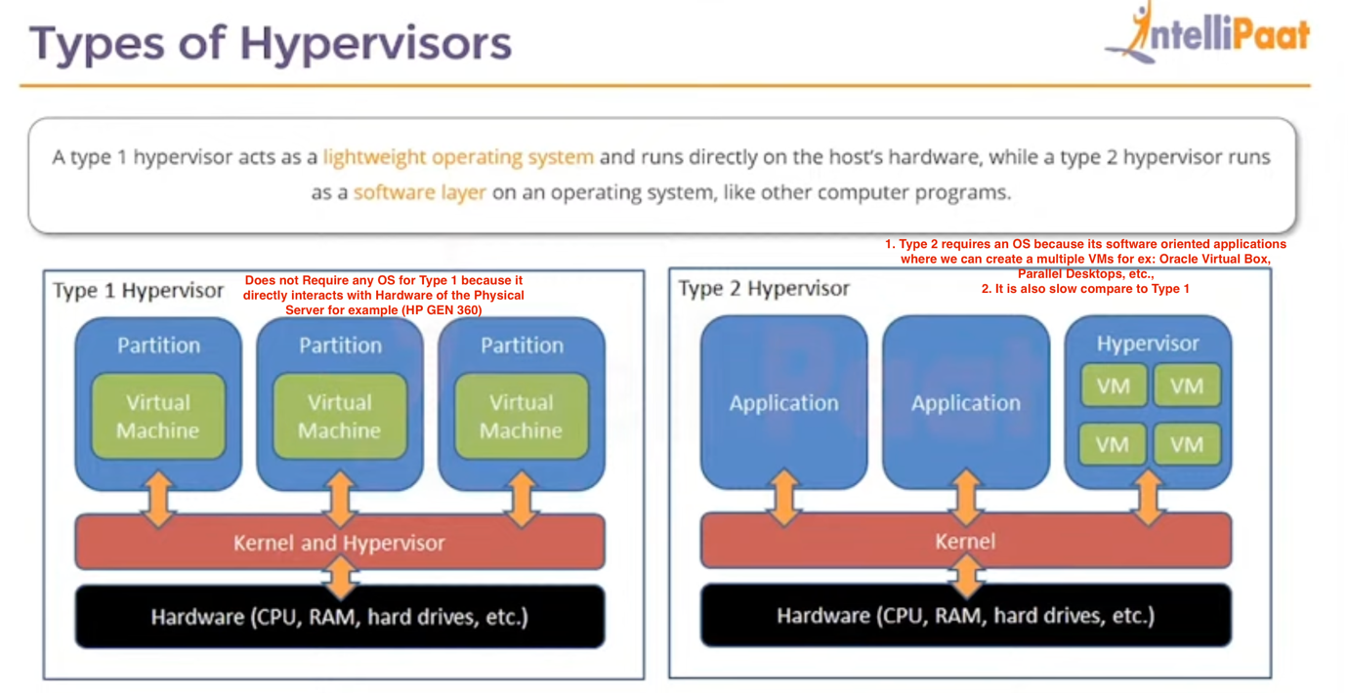

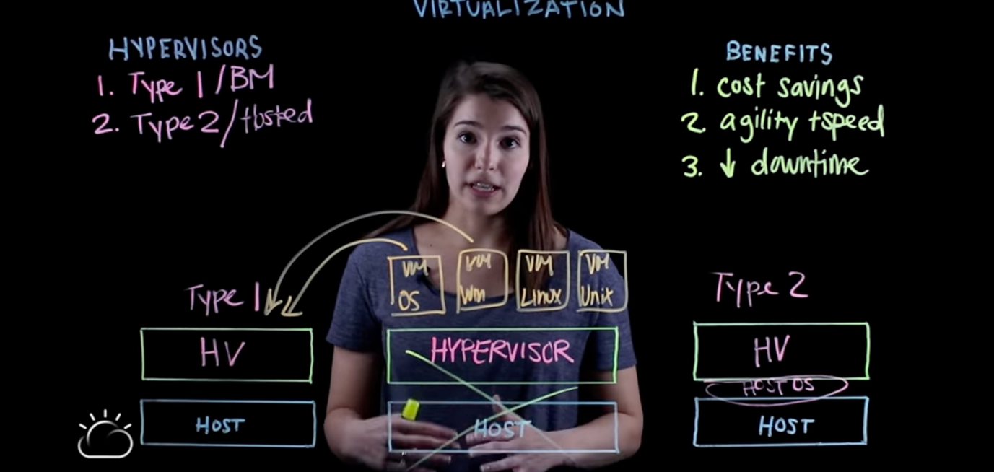

# IGW

* Our machines/internet user’s connections calls come to "Internet Gateway (IGW)" in cloud to connect VPC => It can be created under the "VPC" section
* One IGW Can be attached to only one VPC

================================================

IP Address (https://www.guru99.com/ip-address-classes.html)

* Networks IP address are divided into classes => A, B, C, D, E. We don't use D, E
* How subnets are being calculated ex below?
  + /8 => 255.0.0.0
  + /9 => 255.128.0.0
  + /10 => 255.192(128+64).0.0
  + /16 => 255.255.0.0 => Amazon always use /16
  + /24 => 255.255.255.0
* 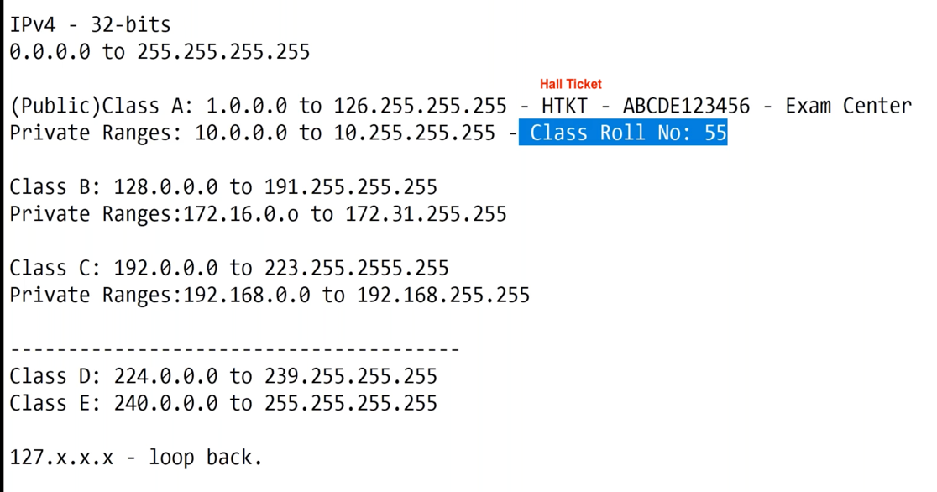

## Subnet Calculation

255.255.255.255 is equals to 24 bits => 11111111. 11111111. 11111111. 11111111

255 => 11111111

2^ value for each index=> 76543210 => total sum of 2 Power (2^) all values is => 255 this is how IP address are being calculated.

* Question? => Derive & tell the IP address range start & end for 10.0.0.0/9 (ignore start ‘10’ and ‘255’)
* 10.0.0.0/9 to final ip range (in bytes) => 11111111.10000000.00000000.00000000

2^ values => 76543210.70000000.00000000.00000000

sum of => 255 + 2^7 (128) + 0 + 0

final IP range => 255.128.0.0

**Answer: 10.0.0.0 to 255.128.0.0**

### Page 1

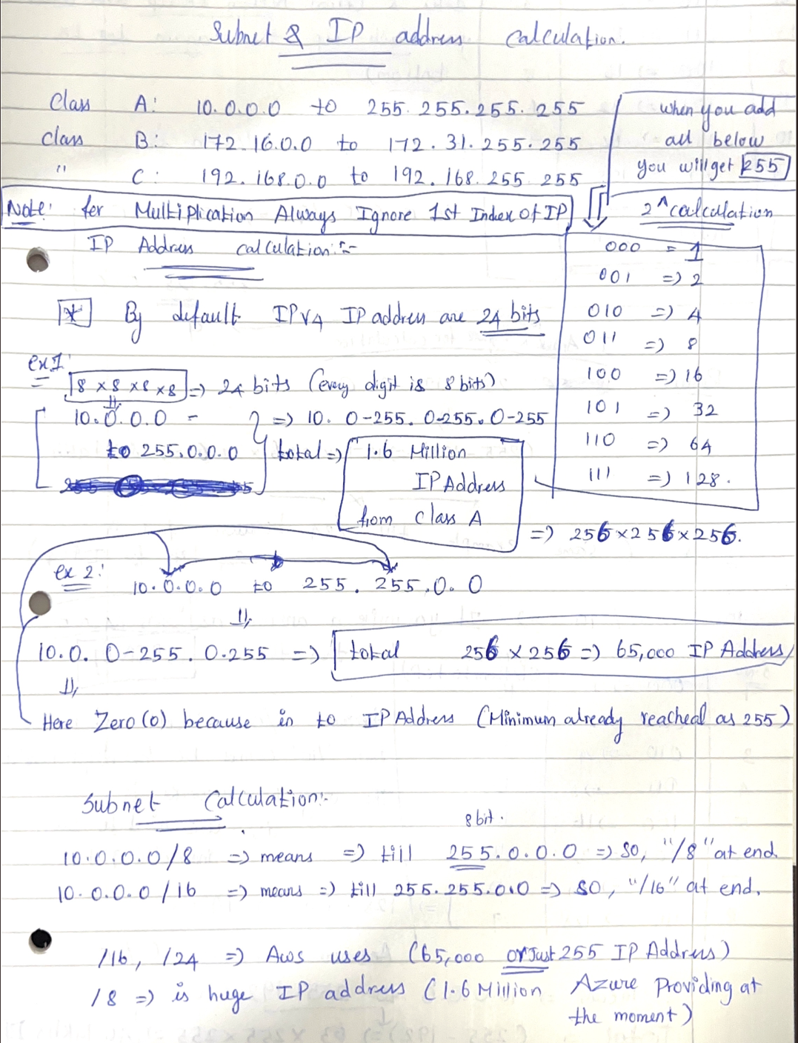

### Page 2

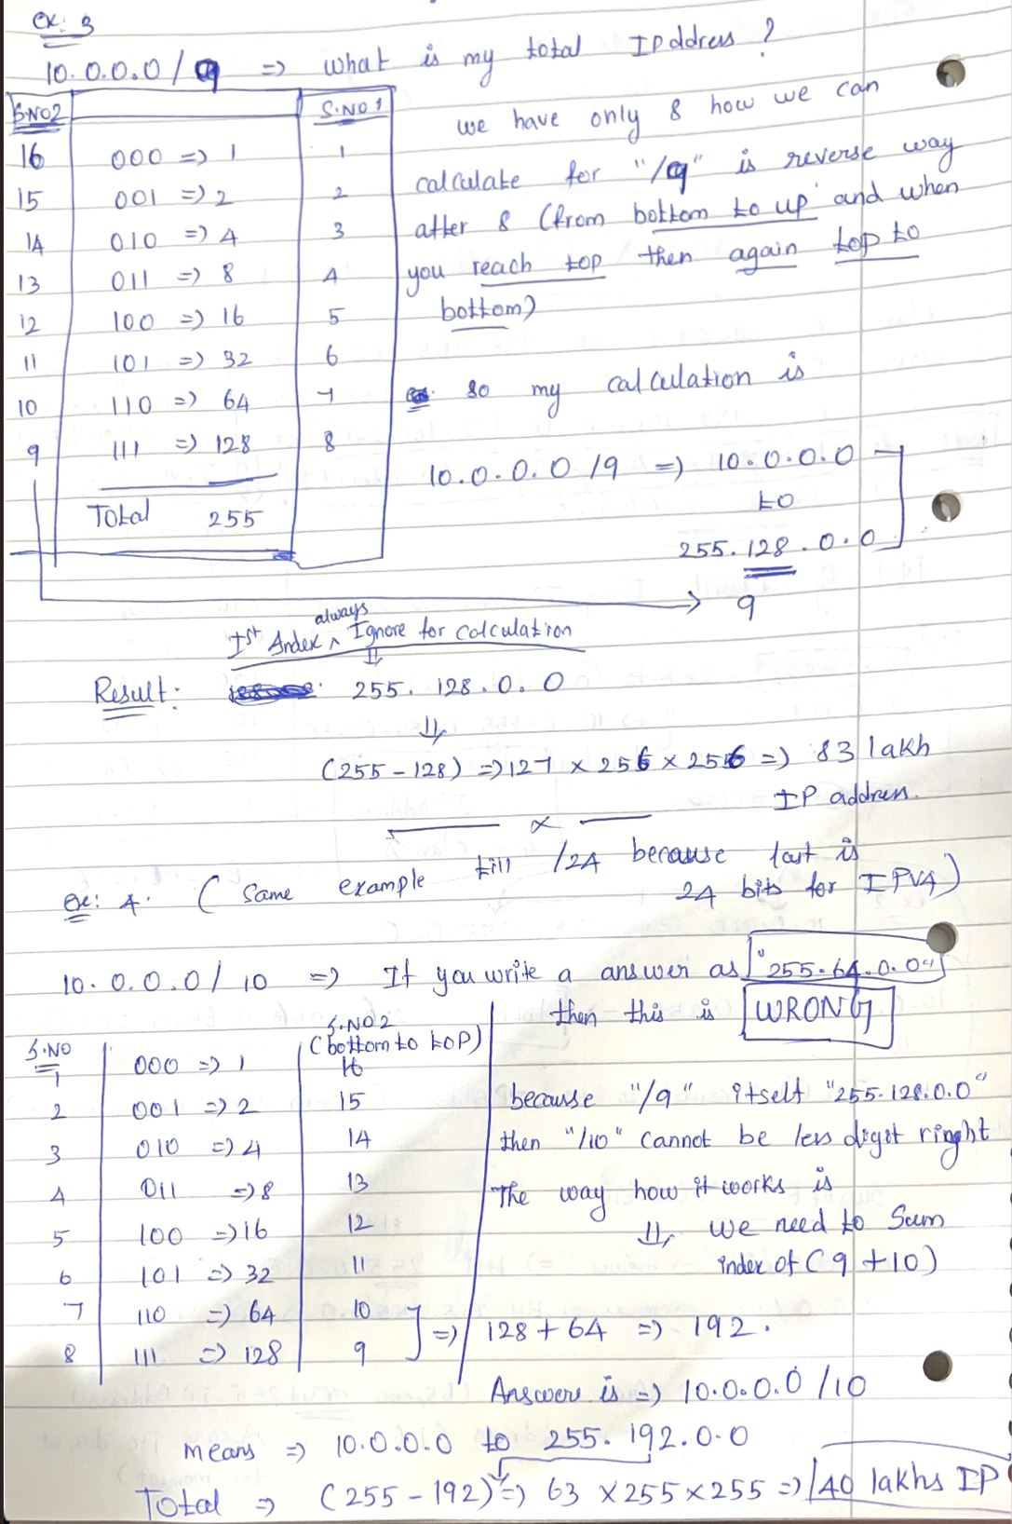

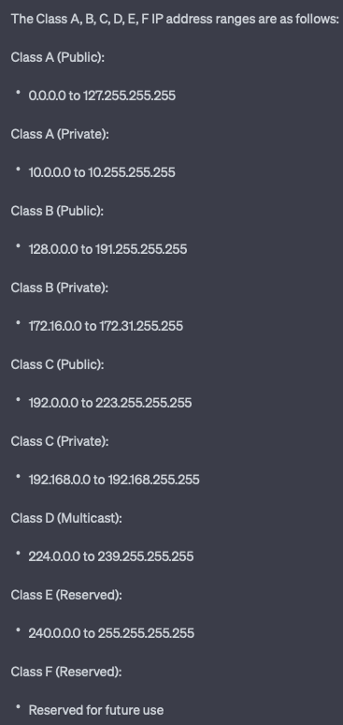

================================================

VPC (with root subnet as 16)

* VPC introduced to have a security layer of the architecture and servers
* Avoid the IP address overlapping issue between other VPC’s or company
* 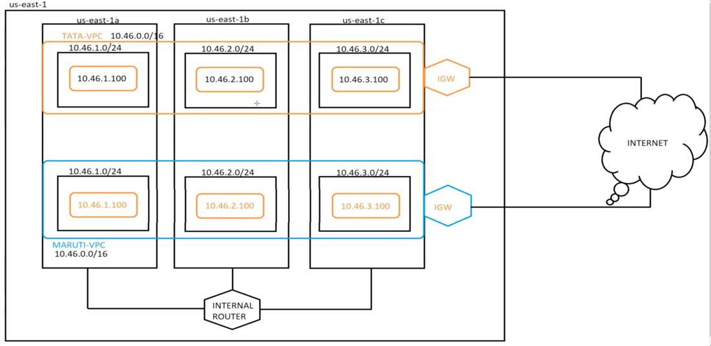
* One VPC can be attached to one IGW only.
* Routing table inside the VPC/Virtual Machine will have the connection to public internet

## Steps to create a VPC

* **for ex:** 10.1.0.0/16 => Then enable DNS Hostname (For Server to use it)
* Mention the VPC name as "ABC" Company
* Create a Subnets and Enable Auto Assign IP (always subnet should follow 24 as instructed by AWS)
  + App Server => 10.1.1.0/24
  + Web Server => 10.1.2.0/24
  + DB Server => 10.1.3.0/24
  + Right click each server then select the "Modify auto-assign IP settings" and enable the "Auto Assign IP"
  + After you created three above subnets under the VPC and Availability zone you could see the "Available IPv4 is 251" in top menu. It is because below calculation (Ex; - App Server)
  + 10.1.1.0/24 => 10.1.1.0 to 10.1.1.255
  + 10.1.1.0 => Used as Network ID won't be used and given to others
  + 10.1.1.255 => Called as Broadcast ID, can’t use
  + 10.1.1.1, 10.1.1.2, 10.1.1.3 => Used for AWS Firewall Gateways
  + Then remaining left to be used for our "ABC" Subnets is 10.1.1.4 => 10.1.1.254
* Create a IGW then attach it to "ABC" VPC
* Create your own Routing table (instead of default table provided by AWS for your VPC) and attach it to your "ABC" vpc
* Then we need to associate the created subnets earlier to this routing table
* Add another route as "0.0.0.0/0" under the "Route" tab and select the target as created IGW which is used for public internets
* create a new security group then map with VPC and put the inbound rules (for ex: Allow all => 0.0.0.0/0). By default, Outbound rules are configured by AWS

## EC2 Instance

• Create a Keypair to connect the EC2 (under the EC2 menu) and download .PEM file (which considered as key)

• Create a new EC2 instance with above created security group and launch

• you can connect the created EC2 instance from your machine with the help of PEM file.

## Deleting an VPC in AWS

* First Detach the Virtual Private Gateways (if any attached to VPC) or else still the costs will occur and you will get the bill even though if VPC’s are deleted

# NAT

* NAT means Network Address Translation and any Server as part of NAT Subnet/NAT Gateway it’s considered **Private Subnet.**
* NAT Subnet & servers inside cannot be accessed directly from Public IP address it should be access from public VM/Subnet (refer point 2 below).
* NAT Gateway works as WIFI Router, for ex: - where it connected to multiple devices. It will hide your original IP address of your VM/Subnet and all the request and response go&flow will be using Elastic IP address of NAT Gateway
* 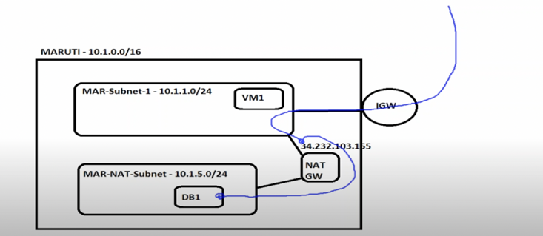
* Create a new Subnet name it as ABC-NAT-DB-Subnet with following IPv4 10.1.5.0/24
* Create a NAT gateway and select App Server-Subnet-1 (which is public subnet not the recently created subnet for NAT). Because the NAT subnet you created in 1st Point here all the requests/operations/manage it should go via your App Server-Subnet-1 to ABC-NAT-DB-Subnet
* Create a new routing table **specific to NAT Subnet**s named as ABC-NAT-Table & add NAT Subnet to it.
* Create route towards NAT Gateway so that all traffic sent by DB server will go to NAT Gateway.
* Deploy VM1 in Public Subnet and DB1 in Private Subnet.
* Try to connect DB1 Server using pubic IP and it should fail
* Login to VM1 and from there connect to DB1
* Ping www.google.com from DB1 and it should work.
* ﻿﻿Prove the data is going through NAT Gateway.

# Load Balancer for subnets

* First, we need to create Target Groups (EC2=>Target Groups) because target groups are the place where we select all the EC2 instances (private / public).
* Secondly, we need to create Load Balancer (EC2 => Load Balancer => ALB) and select the VPC and always select the public subnets (not the EC2 instances). If you select private then you see an error from AWS that it will not be useful
* After that choose the created Target groups in ALB screen so that created ALB when it receives a request then it routes to target groups (EC2 instances)
* 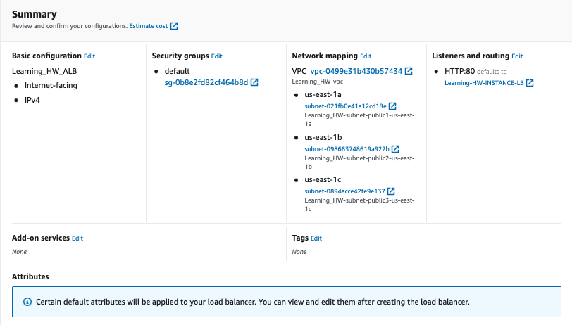
* Select Load Balancer Screen again and wait for status to be **“Active”**
* Then copy the DNS Name and open in browser and keep refresh you can see the nginx ip address does keep change in the bottom of screen. Additionally, we can check through inside the public EC2 instance writing a script and see where the load is.
* 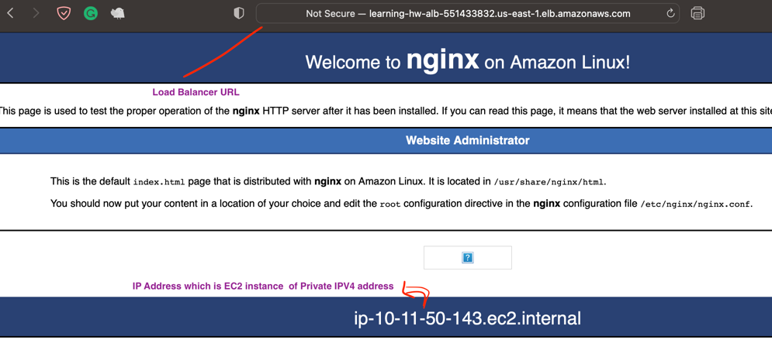
* 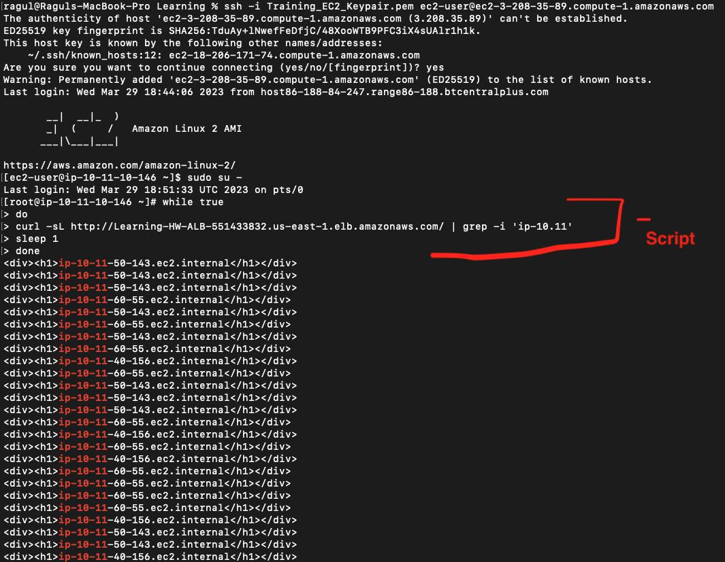

## NLB

I’ve created the NLB with two az’s (us-east-1a & 1b) and each az’s has two public subnets ec2 linux machine.

Then create two Target groups for each az’s (us-east-1a => TCP 80 , us-east-1b=> TCP 22)

* I’ve also created the Route53 Hosted zone as ragulawslearning.shop and created the Aws Certificate manager as (*.ragulawslearning.shop) and associated with it. Inside the Route53 I have created two **Records and added (**[**www.ragulawslearning.shop**](http://www.ragulawslearning.shop) **, app.ragulawslearning.shop)**

To create the GoDaddy domain:

1. Choose the domain name same as route53 (ragulawslearning.shop created for 1 year subscription till Apr 2024)
2. After you paid and created in Godaddy => Select Domain => Change nameservers => Remove the default nameservers => Copy all nameservers from Route53 => Add
3. So that whenever anyone calls this website it directs to aws

* Then come to Load balancers (Select your NLB => Listeners =>Add) select TLS 443 => select the created certificate by AWS
* Also, I have enabled the cross-zone availability to improve performance of traffic and split the traffic equally between the two az’s ( if you did not enable this then traffic from NLB mostly on one az’s)



# Security Group

NACL => Network ACL => it’s a Stateless Firewall => Subnet Level in AWS

SG => Security Group => it’s a Stateful Firewall => Instance Level in AWS

Below is a representation

* Stateful Firewall means if one outbound (ex: - HTTP Port 80) is sent to Internet/User then if any Inbound receives back to server, then SG will assume it’s already been validated and secured connection.
* Stateless Firewall if outbound sent then Inbound packets are dropped at the layer of **NACL.**

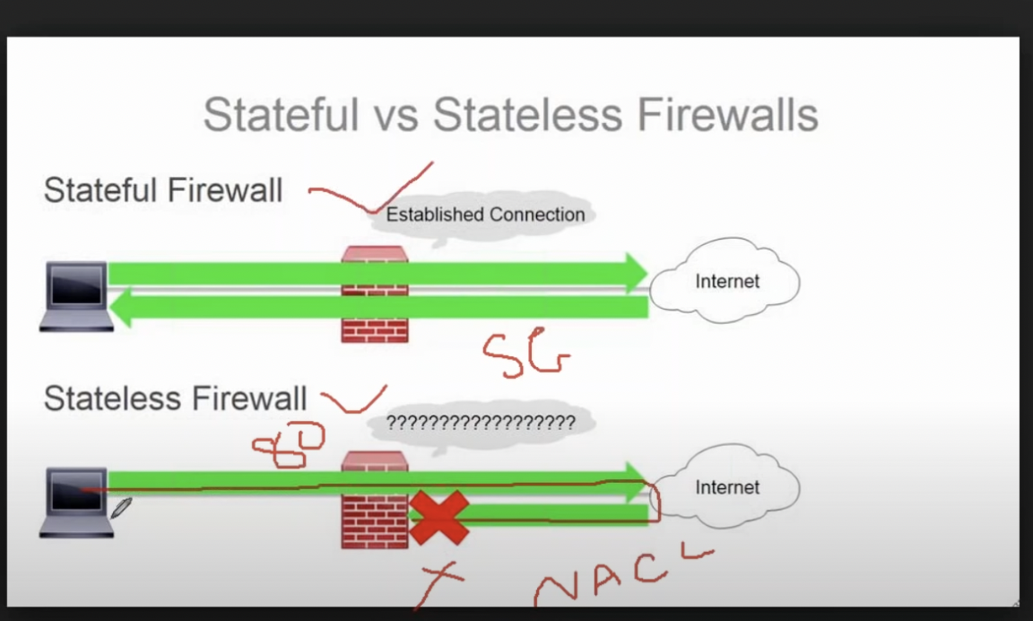

* Create a Security Group (Stateful Firewall) with Inbound and Outbound rules along with 0.0.0.0/0 so that our Server/Subnet can access the Internet when you “ping [www.google.com](http://www.google.com)”. If you specify Inbound but did not specify the Outbound rules then you get “ping” connection timed out. It’s because we did not specify the outbound rules to send the information to internet.
* If you want to control DB server and limit the connection only with your APP Server (Backend)/Management Server (Who handles/manages the DB) then in the security group **Inbound** rules we need to put their Server EC2(Backend) private IP Address. **Forex: PFB image**

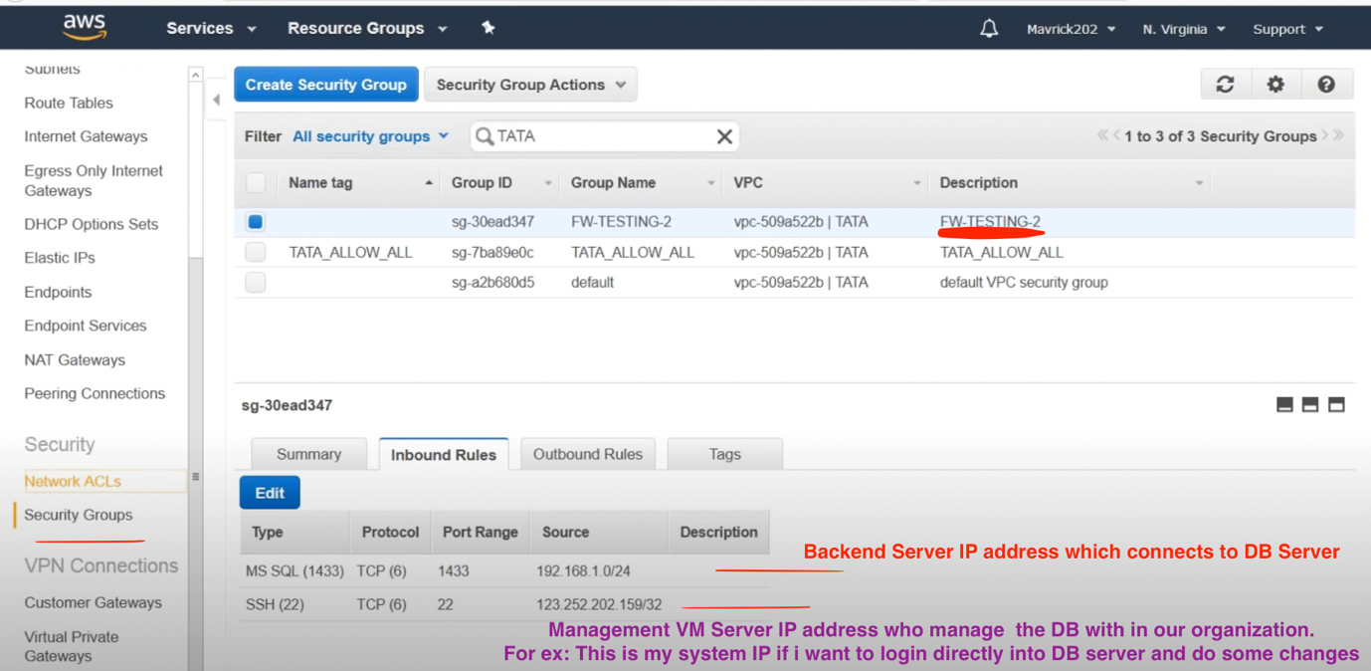

* In Security Groups **-> It only checks the IP Address of request** packets/information whether it’s same as above configured and it will not check the request information whether its valid or any masked data which might corrupt the system. (**For ex:** If an IT employee from Syntel wears Syntel ID card but it’s his friends one not his own). We don’t want this situation right in a real time. So, we can integrate additionally the 3rd Party Security Groups like **F5, Barracuda, etc.,** (while creating the EC2 instance) to place the security guard to check each ID card and their face on it. **This mechanism called IDS (Intrusion Detection System) & IPS (Intrusion Protection System)**
* 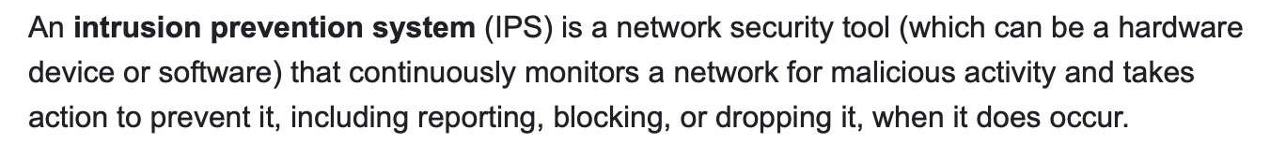
* 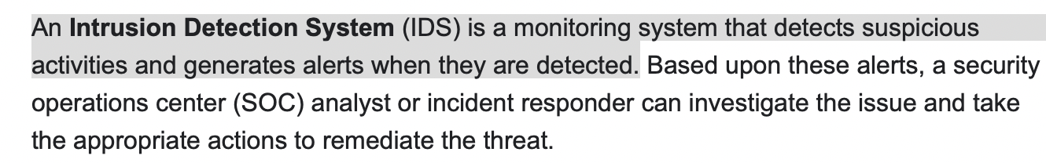

# EBS

* Create a EC2 machine for Linux and Create a New EBS volume for 4G and assign to EC2 instance then do the partition in Linux machine for the newly created EBS volumes through Linux commands
* After partition, then increase the EBS volume in AWS UI from 4G to 6G then extend the extra 2G to file system of already created partition in Linux commands.
* Answer => Refer the PDF document (Linux EC2 Storage EBS volume extension.pdf)